Automation Core Testing (Load Runner Up and Selenium IDE)

# **Which components have you used in Load Runner?**

LoadRunner is a performance testing tool that uses several components to simulate user activity, measure system performance, and analyze results. Some of the key components used in LoadRunner include:

1. Virtual User (Vuser) scripts
2. Controller
3. Load Generators
4. Analysis

These components work together to simulate user activity, measure performance, and analyze results.

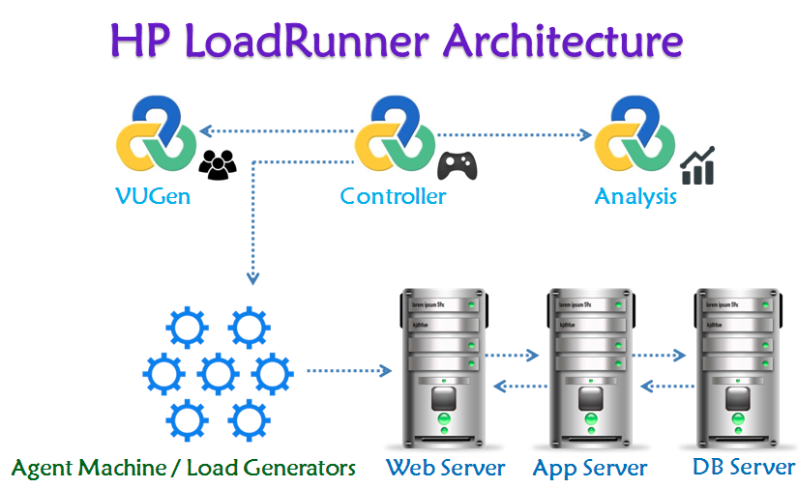

# **How can you set the number of Vusers in Load Runner?**

In LoadRunner, we can set the number of Vusers in the following ways:

* **Controller:** In the Controller, go to "Scenario" > "Vusers" and set the "Number of Vusers" field.
* **Runtime Settings:** In the Vuser script, go to "Runtime Settings" > "General" and set the "Number of Vusers" field.
* **Command Line:** Use the command line option "-n" followed by the number of Vusers, for example: "lr -n 10".

Note: The number of Vusers can also be controlled through the LoadRunner API and through external automation tools.

# **What is Correlation?**

correlation is the process of capturing and replacing dynamic values in a script with unique values for each virtual user (Vuser). This ensures that each Vuser interacts with the application independently, simulating real-user behavior.

* Handle session IDs, tokens, and other unique identifiers
* Simulate unique user inputs, like usernames and passwords
* Capture and reuse dynamic data, such as timestamps or order numbers

By correlating dynamic values, you ensure that your load test accurately reflects real-world usage and avoids errors caused by duplicate or hardcoded values.

# **What is the process for developing a Vuser Script?**

The process for developing a Vuser script in LoadRunner is:

* **Record:** Capture user interactions with the application using LoadRunner's recording tool.
* **Analyze:** Review the recorded script, identify dynamic values, and determine what needs to be correlated.
* **Parameterize:** Replace dynamic values with parameters to enable unique data for each Vuser.
* **Correlate:** Capture and replace dynamic values with correlated data.
* **Script Enhancement:** Add think time, loops, conditional statements, and other logic to simulate realistic user behavior.
* **Verification:** Validate the script's functionality and accuracy.
* **Debug:** Test and debug the script to ensure it runs smoothly.
* **Finalize:** Prepare the script for load testing by setting runtime settings and configuring logging.

This process helps create a robust Vuser script that accurately simulates real-user interactions with the application.

# **When to used Usablity Testing?**

Usability testing helps ensure a positive user experience, identify areas for improvement, and inform design decisions throughout the product development lifecycle.

# **How Load Runner interacts with the application?**

LoadRunner uses software agents called "protocols" to communicate with the application. These protocols mimic real-user interactions by sending requests to the application's servers and receiving responses. The protocols used depend on the application's architecture and technology stack.

Here's how it works:

1. **application Selection:** LoadRunner selects the appropriate protocol (e.g., HTTP, Web Services, Citrix) based on the application's technology.
2. **Script Recording:** LoadRunner records user interactions with the application using the selected protocol, capturing requests and responses.
3. **Script Replay:** During load testing, LoadRunner replays the recorded script, sending requests to the application's servers using the same protocol.
4. **Request/Response:** The application processes the requests and sends responses back to LoadRunner, which analyzes the responses to verify functionality and performance.
5. **Data Correlation:** LoadRunner correlates dynamic data, such as session IDs or tokens, to ensure each virtual user interacts with the application independently.
6. **Generate Load:** LoadRunner generates a large volume of virtual users, each executing the script and interacting with the application, simulating real-world usage.

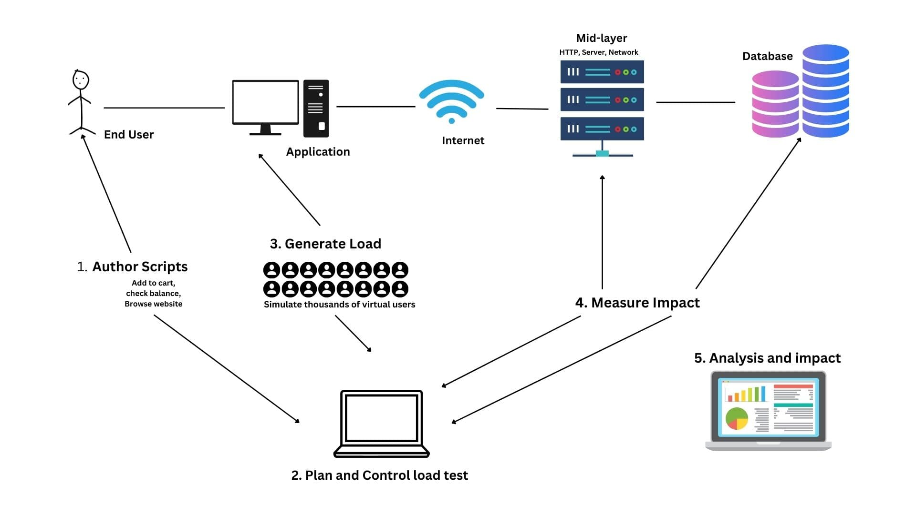

# **How many VUsers are required for load testing?**

The number of VUsers (Virtual Users) required for load testing depends on several factors, including:

**1. Expected user load:** Estimate the number of real users who will be using the application simultaneously.

**2. Application complexity:** More complex applications may require more VUsers to simulate realistic usage.

**3. Test goals:** Identify what you want to achieve with load testing (e.g., peak performance, stress testing).

**4. Hardware resources:** Ensure the load testing environment can handle the desired number of VUsers.

Here are some general guidelines:

* **Low-load testing:** 10-50 VUsers (e.g., small applications, development testing)
* **Medium-load testing (Stress):** 50-200 VUsers (e.g., medium-sized applications, performance testing)
* **High-load testing (Scalability):** 200-1,000 VUsers (e.g., large applications, stress testing)
* **Extreme-load testing (flood):** 1,000+ VUsers (e.g., very large applications, extreme stress testing)

Remember, the key is to simulate realistic user behavior and gradually increase the load to measure the application's performance and identify bottlenecks.

# **What is the relationship between Response Time and Throughput?**

Response Time and Throughput are two related but distinct performance metrics:

**- Response Time:** The time it takes for an application to respond to a user request or action. It measures how long a user must wait for a response.

**- Throughput:** The number of user requests or actions an application can handle within a given time period (e.g., transactions per second).

The relationship between Response Time and Throughput is:

* Inverse correlation: As Throughput increases (more requests handled), Response Time typically decreases (faster responses).
* Trade-off: Improving one metric can impact the other. For example, optimizing for faster Response Times might reduce Throughput, and vice versa.
* Balance: Aim for a balance between Response Time and Throughput to ensure a good user experience and efficient system performance.
* In load testing, analyzing both Response Time and Throughput helps identify performance bottlenecks and optimize application performance.

# **What determines the level of risk?**

The level of risk is determined by several factors, which can vary depending on the context and type of risk.

* How likely something is to happen **(probability)**
* How bad the outcome could be **(impact)**
* How vulnerable you are to harm **(vulnerability)**
* Whether there are safeguards in place **(mitigating factors)**

# **Mention what are the categories of defects?**

Defects can be categorized into several types, including:

* **Critical:** The defects will cause downstream damage.
* **Major:** The defects could cause a downstream damage.
* **Minor:** The defects are highly unlikely to cause the downstream damage

# **Difference between Priority and Severity**

|  |  |
| --- | --- |
| **Priority** | **Severity** |
| Refers to the impact or potential impact of a defect on the system, user, or business. | Refers to the order in which defects should be addressed or fixed |
| Measures the potential damage or risk caused by the defect. | Determines the urgency and importance of resolving the defect. |
| Typically categorized as:  - Critical (High)  - Major (Medium)  - Minor (Low) | Typically categorized as:  - High (Must-fix, critical)  - Medium (Should-fix, important)  - Low (Nice-to-fix, minor) |
|  |  |

# **What is Bug Life Cycle?**

The Bug Life Cycle, also known as the Defect Life Cycle, is the process that a bug or defect goes through from the time it is detected to the time it is resolved. The typical stages of the Bug Life Cycle are:

* **New:** The bug is detected and reported.
* **Assigned:** The bug is assigned to a team or individual for further investigation.
* **Open:** The bug is confirmed and accepted for fixing.
* **In Progress:** Work on resolving the bug has started.
* **Resolved:** The bug is fixed and verified.
* **Verified:** The fix is tested and confirmed to be correct.
* **Closed:** The bug is closed, and the issue is considered resolved.
* **Reopened:** If the bug reappears or the fix is incomplete, it is reopened.

This life cycle ensures that bugs are properly tracked, managed, and resolved in a systematic and efficient manner.

# **What is priority?**

Priority refers to the level of importance assigned to a task, bug, or issue, determining the order in which it should be addressed or resolved.

High (Critical), Medium (Major), Low (Minor)

# **What is severity?**

Severity refers to the potential impact or damage that a bug, defect, or issue can cause to a system, application, user, or business.

Critical (High), Major (Medium), Minor (Low), Trivial (Very Low)

# **Advantage of Bugzila.**

Bugzilla's advantages make it a popular choice for bug tracking and management in software development teams.

* **Open-source:** Free to use and modify.
* **Customizable:** Tailor it to your team's needs.
* **Scalable:** Handles large numbers of bugs and users.
* **User-friendly:** Intuitive interface for easy bug tracking.
* **Searchable:** Powerful search functionality for quick bug lookup.
* **Reporting:** Generate detailed reports on bug trends and metrics.
* **Collaboration:** Assign, track, and discuss bugs with team members.
* **Version control:** Track bugs across different product versions.
* **Security:** Granular access control and security features.
* **Community support:** Active community and extensive documentation.
* **Integration:** Integrates with various tools and platforms.
* **Stability:** Reliable and stable bug tracking system.